ITM University Gwalior
School of Computing and Intelligent Systems
Project-Based Learning (PBL)
Mini Project Report — Submission Report

Course: Data Analytics Using Python
Course Code: CSL0312
Program: B.Tech. CSE (Artificial Intelligence & Machine Learning)
Semester: III Section:
Academic Session: July–Dec 2026
Project Details
Project Title: Analysing the Association of Age and Sex with Diabetes Occurrence: An Exploratory Data Analysis Using the CDC Diabetes Health Indicators Dataset
Domain (as per Section 6): Healthcare
Team Leader Name & Roll No.: Anvesha Singh(BETN1AI25111)
Team Member Name & Roll No.: Priya Kanshana(BETN1AI25108)
Team Member Name & Roll No.: Jampalli Anyasree(BETN1AI25120)
Faculty Mentor: Dr.Sanjay Jain
Date of Submission: 16-10-2026

1. Introduction & Problem Statement
1.1 Introduction
Diabetes is a health condition that can affect a person's overall well-being. Studying how diabetes occurrence varies across different groups can help us understand patterns in health-related data.
This project uses the CDC Diabetes Health Indicators dataset to explore the association between age, sex and recorded diabetes status. Python is used to examine the dataset through exploratory data analysis, descriptive statistics and visualisation. BMI, high blood pressure and high cholesterol are also considered as supporting variables to understand how recorded diabetes status varies with selected health indicators.
The analysis focuses on identifying patterns and associations in the available data. It does not aim to predict diabetes or establish that any particular variable causes diabetes.
1.2 Problem Statement
The project aims to analyse the association of age and sex with diabetes occurrence using the CDC Diabetes Health Indicators dataset. It also examines selected health-related indicators, including BMI, high blood pressure and high cholesterol, to identify differences in recorded diabetes status across these categories.
The main objective is to understand the patterns present in the dataset through exploratory data analysis and statistical methods, and to interpret the findings based on the available data.

2. Dataset Description & Source
Dataset Name: CDC Diabetes Health Indicators Dataset
Source / Organization: UCI Machine Learning Repository
Dataset Link (URL): https://archive.ics.uci.edu/dataset/891/cdc+diabetes+health+indicators
Type of Dataset: ☑ Public ☐ Private ☐ Self-Collected
Number of Records: 253,680
Number of Attributes/Columns: 22
Brief description of attributes/columns:
The dataset contains demographic, health-related and lifestyle indicators used to study patterns in recorded diabetes status. The main attributes relevant to this project are:
- Diabetes_binary: Recorded diabetes-status target variable.
- Age: Age group of the respondent.
- Sex: Sex category recorded in the dataset.
- BMI: Body Mass Index.
- HighBP: Indicator of high blood pressure.
- HighChol: Indicator of high cholesterol.
Other attributes include cholesterol check status, smoking, stroke history, heart disease, physical activity, fruit and vegetable consumption, general health, physical and mental health, difficulty walking, education and income.
☑ Dataset meets minimum quality criteria (Section 7) — The dataset contains more than 500 records and more than 5 attributes. The missing-value check in the project analysis found no missing values.

3. Data Cleaning & Preprocessing
The CDC Diabetes Health Indicators Dataset was checked for missing values, duplicate records, data types, and variable consistency before performing exploratory data analysis. The preprocessing steps focused on preparing the variables required to study the association of age and sex with diabetes occurrence.
3.1 Handling Missing Values
A missing-value check was performed across all columns of the dataset. No missing values were found, so no imputation or removal of records due to missing data was required.
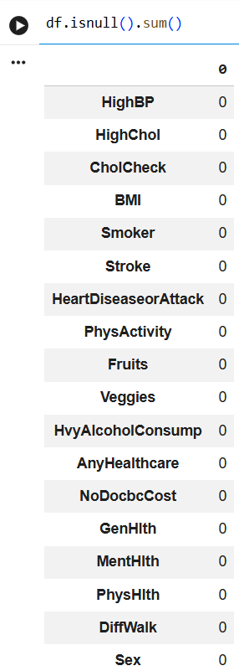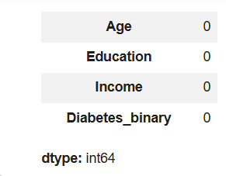
Observation: No missing values were found in the dataset.
3.2 Duplicate Records
Duplicate records were checked to understand the quality of the dataset. A total of 24,206 duplicate rows were identified. These rows were retained in the analysis.
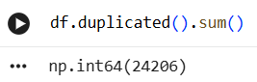
Observation: The dataset contained 24,206 duplicate rows, which were identified but not removed.
3.3 Data Types and Variable Preparation
The dataset contains 253,680 records and 22 columns. The relevant variables used in the analysis include Diabetes_binary, Age, Sex, BMI, HighBP, and HighChol. The age and sex codes were interpreted according to the dataset documentation.
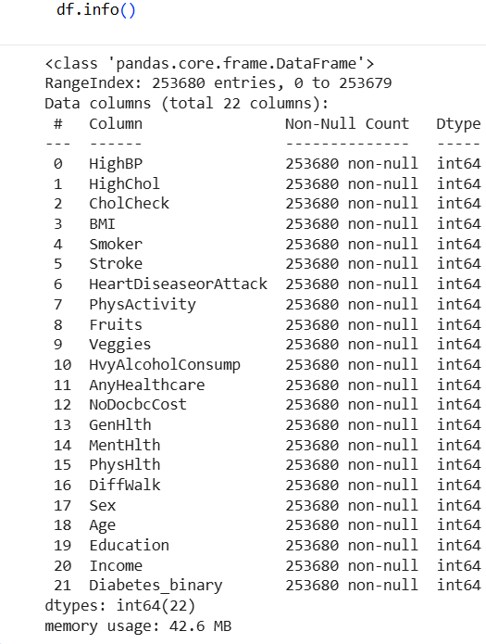
Observation: The dataset structure and data types were examined to understand the variables before analysis.

3.4 Data Encoding and Categorization
The Age variable represents coded age groups, while Sex is coded as 0 for Female and 1 for Male. BMI was categorized into four groups: Underweight, Normal, Overweight, and Obese. These categories were used to compare diabetes-status rates across BMI groups.
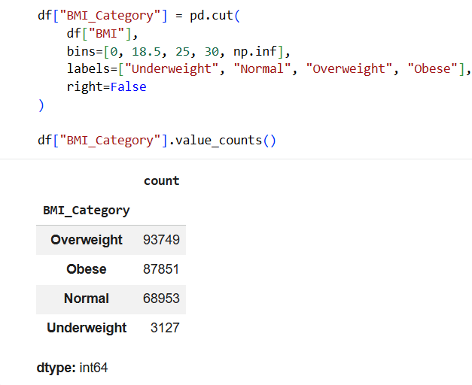
Observation: BMI was grouped into four categories to support comparisons and statistical analysis.
3.5 Outliers and Scaling
BMI was examined using descriptive statistics and categorized for further analysis. No claim is made that outliers were removed or modified. Normalization and feature scaling were not required because the project focused on exploratory data analysis, visualizations, cross-tabulations, and statistical association tests rather than predictive modelling.
Observation: The analysis used the available data without claiming that outliers were removed or numerical variables were scaled.
3.6 Preprocessing Summary
The dataset was checked for missing values, duplicate records, and data types. Relevant variables were interpreted using the dataset definitions, and BMI was categorized for comparison. No missing-value imputation was required. Duplicate rows were retained, and the prepared dataset was used for exploratory data analysis and statistical testing.

4. Exploratory Data Analysis (EDA)
Exploratory Data Analysis (EDA) was performed to understand the distribution of diabetes status and examine its association with age, sex, BMI, high blood pressure, and high cholesterol. Summary statistics, frequency distributions, and group-wise comparisons were used to identify patterns in the dataset.
4.1 Distribution of Diabetes Status
The frequency and percentage distribution of Diabetes_binary were examined to understand the number of records in each target category.
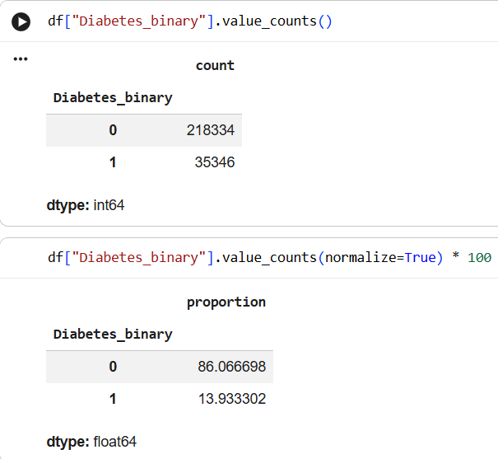
Observation:
- Category 0: 218,334 records (86.07%).
- Category 1: 35,346 records (13.93%).
Category 0 accounted for the larger proportion of the dataset.

4.2 Age-Group Analysis
The percentage of records in category 1 generally increases across the age groups. It rises from 1.37% in the 18–24 age group to a maximum of 21.85% in the 70–74 age group. The percentage then decreases to 21.30% for ages 75–79 and 18.48% for ages 80 and above.
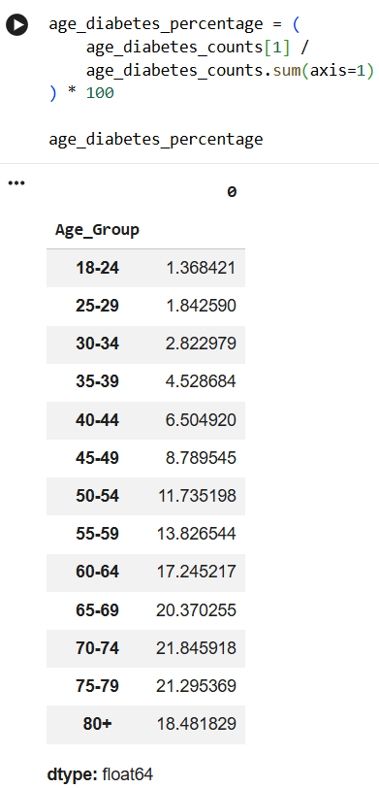
observations:
- The lowest percentage is 1.37% for the 18–24 age group.
- The highest percentage is 21.85% for the 70–74 age group.
- The percentage declines in the two oldest age groups after reaching its maximum.
The age variable represents coded age groups rather than exact individual ages.
4.3 Sex-Based Analysis
The percentage in category 1 is 12.97% for sex code 0 and 15.16% for sex code 1. According to the dataset coding, sex code 0 represents female and sex code 1 represents male.
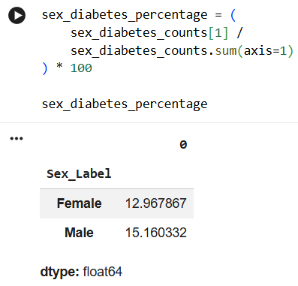
The observed percentage is higher among male-coded records. This is a descriptive difference and does not establish a causal relationship.
4.4 BMI Analysis
Descriptive statistics were used to examine the distribution of BMI values. The mean BMI is 28.38, while the median is 27. The BMI values range from 12 to 98 in the dataset
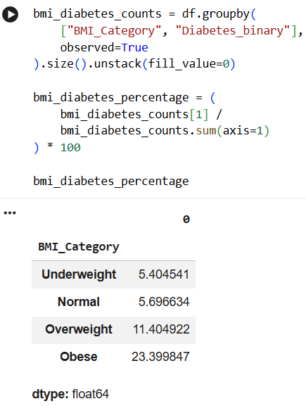

The percentage increases across the BMI categories, with the highest value in the obese category. These results show an association in the dataset but do not prove that BMI causes the recorded outcome.
4.5 High Blood Pressure Analysis
The percentage in category 1 is 6.04% among records with HighBP = 0 and 24.45% among records with HighBP = 1.
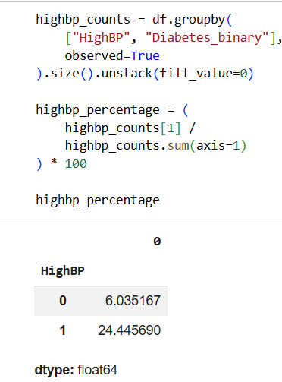
The percentage is higher among records where high blood pressure is recorded. This indicates an association within the dataset, not proof of causation.
4.6 High Cholesterol Analysis
The percentage in category 1 is 7.98% among records with HighChol = 0 and 22.01% among records with HighChol = 1.
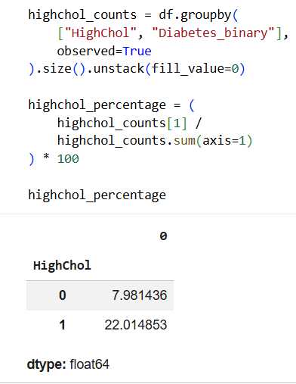
The percentage is higher among records where high cholesterol is recorded. This comparison describes an association in the dataset and does not establish a cause-and-effect relationship.
4.7 Patterns Identified
The exploratory analysis revealed the following patterns:
- Category 0 represented most records in the dataset.
- The category 1 rate generally increased with age, reaching its highest recorded value at age code 11.
- Male records had a higher category 1 rate than female records.
- The obese BMI category had a higher category 1 rate than the other BMI categories.
- Records with high blood pressure and high cholesterol had higher category 1 rates than records without these indicators.
These findings describe patterns and associations within the dataset; they do not establish cause-and-effect relationships.

5.Data Visualization & Observations

Data visualization was used to examine the distribution of diabetes status and explore its association with age, sex, BMI, high blood pressure and high cholesterol. Bar charts, a boxplot and heatmaps were used to present the patterns observed in the dataset.
5.1 Age-wise Analysis
The age-wise analysis compares the percentage of individuals in diabetes-status category 1 across different age groups. The percentage generally increases across the age groups, reaching approximately 21.85% at age code 11 before declining slightly in the oldest groups.
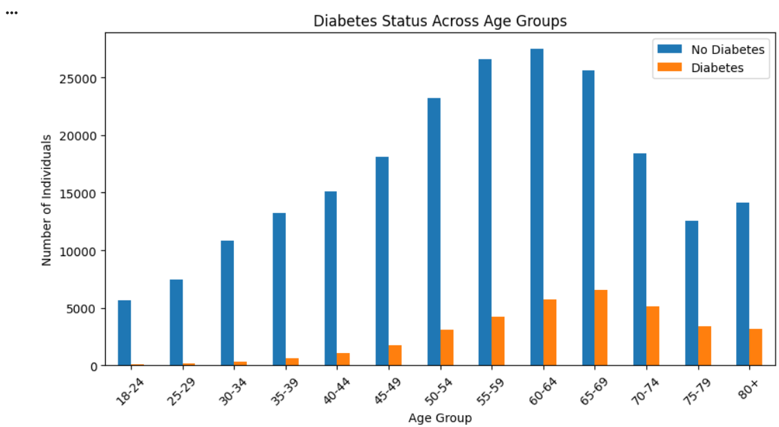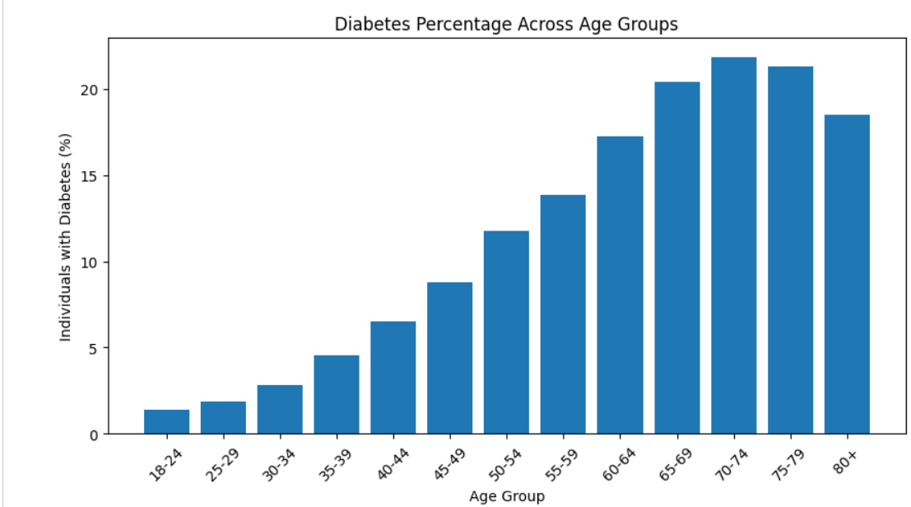
5.2 Sex-wise Analysis
The sex-wise analysis compares the percentage of individuals in diabetes-status category 1 between males and females. The observed percentage is 15.16% among males and 12.97% among females. This shows a difference between the two groups in the dataset.
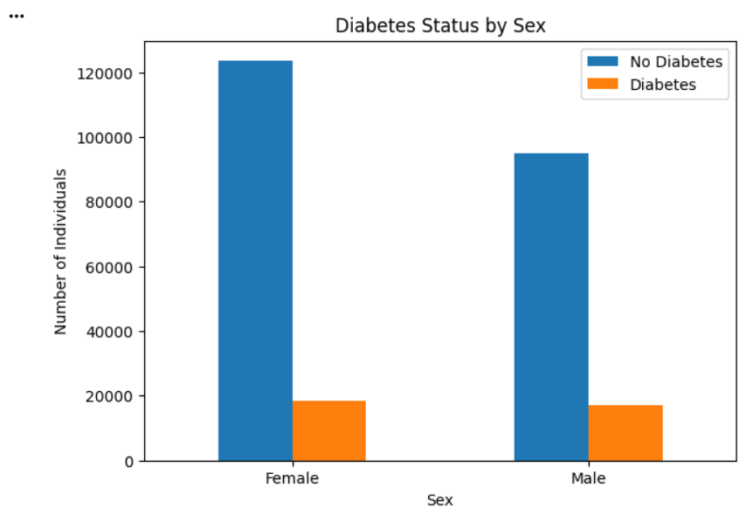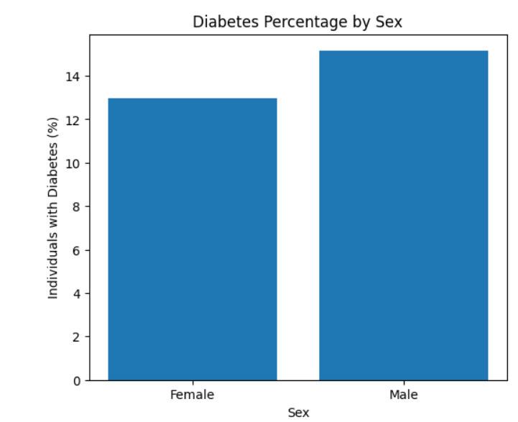
5.3 Combined Age and Sex Analysis
The combined analysis examines diabetes percentage across age groups separately for males and females. It allows the differences between the two sex categories to be compared across age groups.
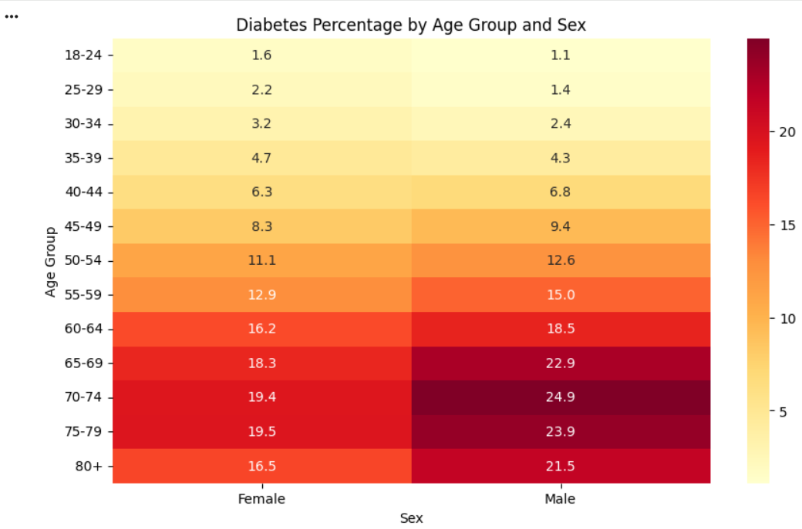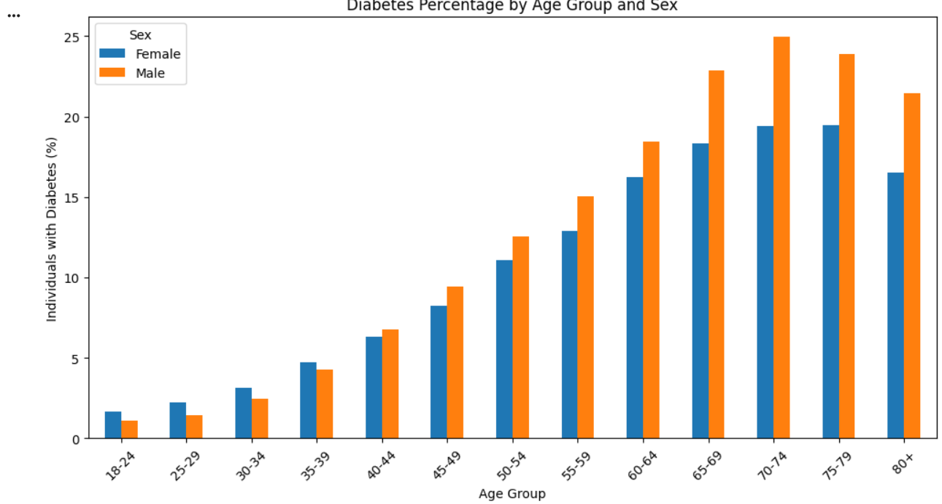

5.4 BMI and Diabetes
BMI was examined using a boxplot and a comparison of diabetes percentages across BMI categories. The percentage in diabetes-status category 1 is higher in the obese category (23.40%) than in the normal BMI category (5.70%).
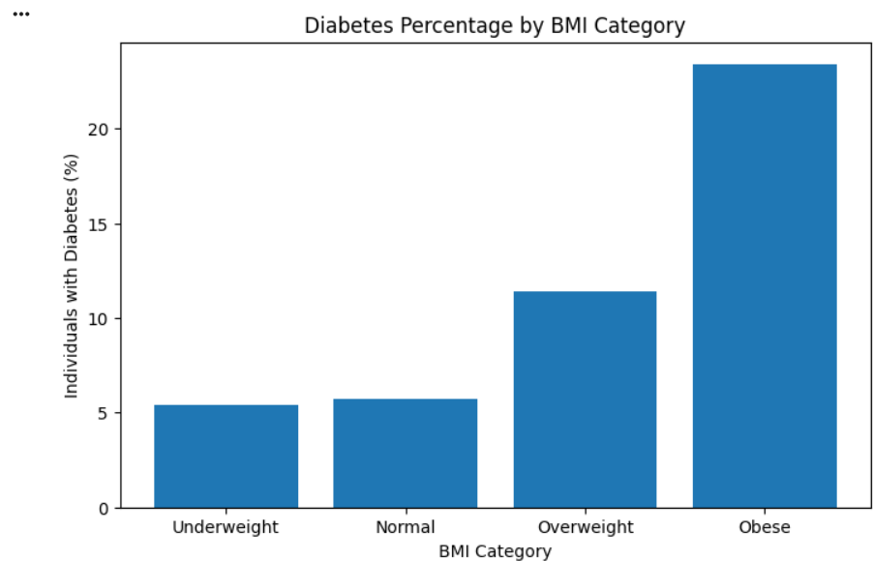
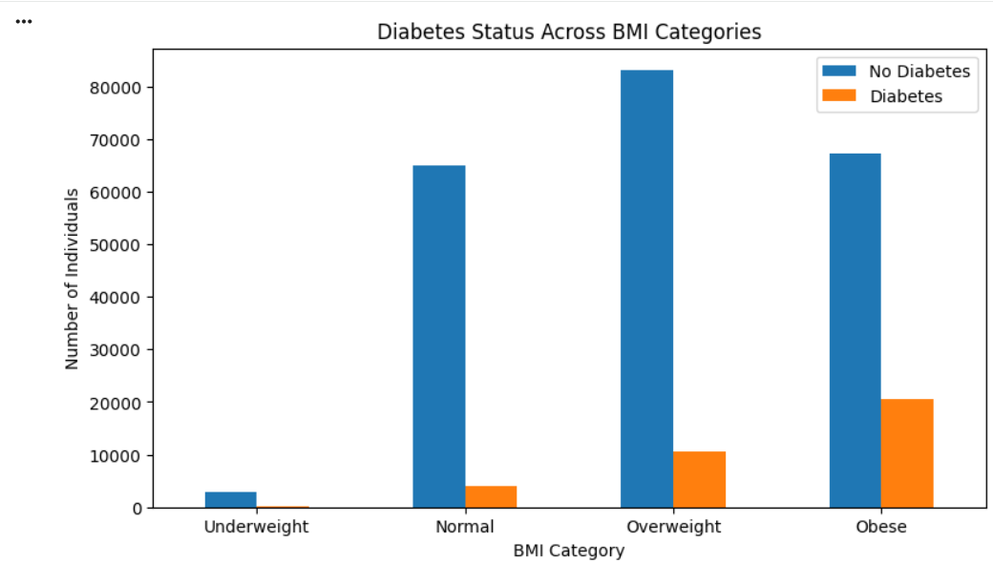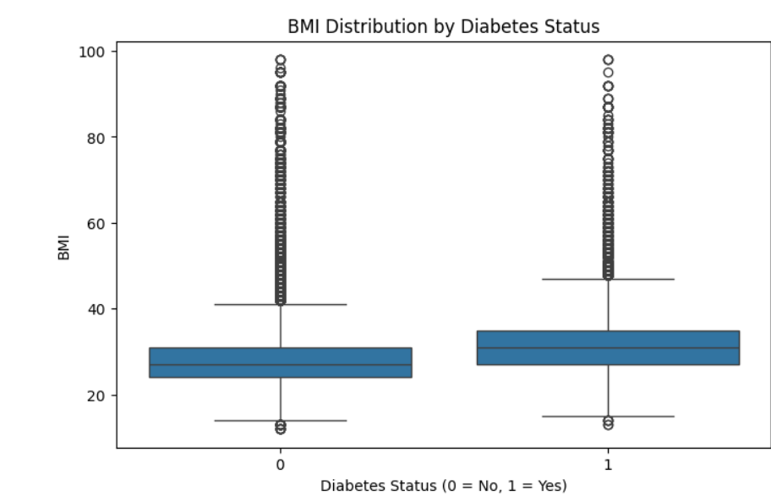
5.5 Other Health Indicators
High blood pressure and high cholesterol were examined to compare the percentage of individuals in diabetes-status category 1 between records with and without each condition.
The percentage is 24.45% among records with high blood pressure and 6.04% among records without high bl ood pressure. For high cholesterol, the corresponding percentages are 22.01% and 7.98%.
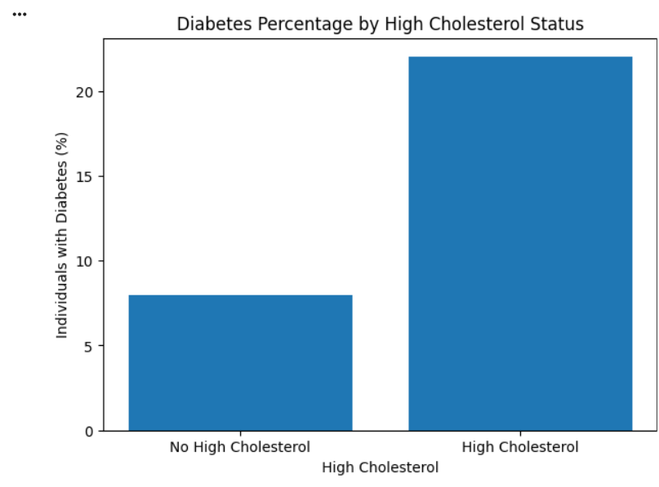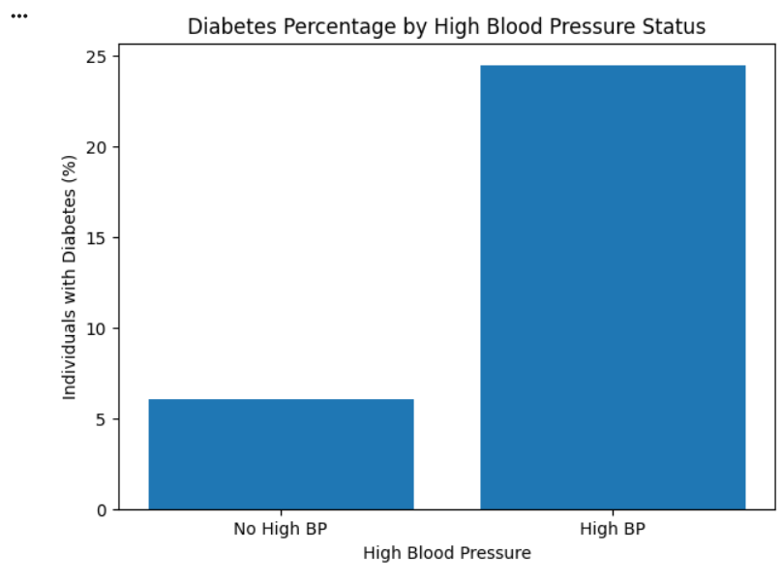
5.6 Correlation Heatmap
The correlation heatmap presents the correlation coefficients among the selected numerical variables. It provides an overview of the direction and strength of linear relationships between the variables included in the heatmap.
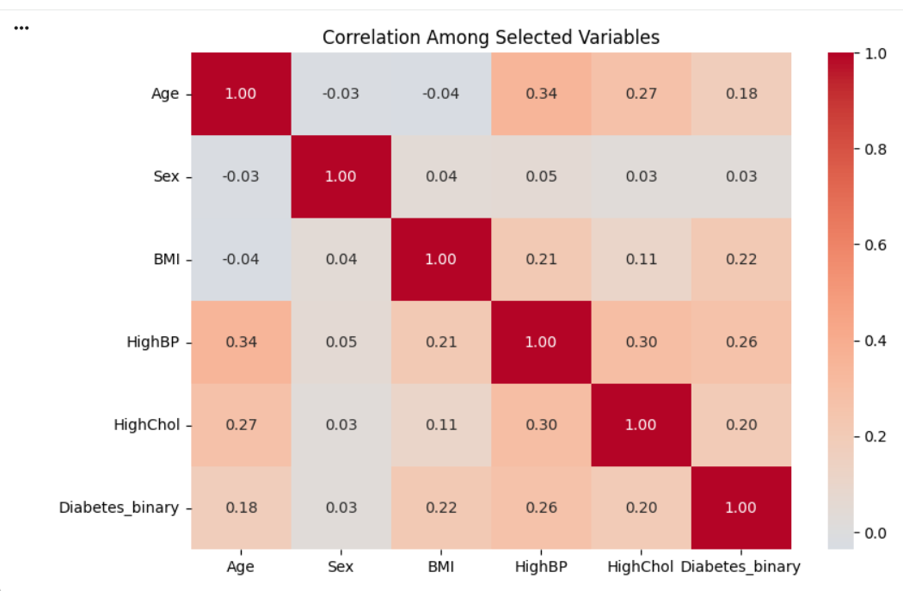
The heatmap should be interpreted using the actual correlation coefficients displayed in the notebook. Correlation does not establish causation.
5.7 Summary of Observations
The visualizations show differences in recorded diabetes status across age groups, sex, BMI categories, high blood pressure and high cholesterol. The combined age-and-sex heatmap allows comparisons across both demographic variables, while the correlation heatmap summarizes relationships among selected numerical variables. These visual observations complement the statistical tests presented in Section 6.

6. Statistical Analysis (Basic)
Statistical analysis was performed to examine the association between recorded diabetes status and age group, sex, BMI category, high blood pressure and high cholesterol. The Chi-square test of independence and Cramér’s V were used for this analysis.
6.1 Descriptive Statistics
Descriptive statistics were used to understand the distribution of recorded diabetes status and BMI in the dataset.
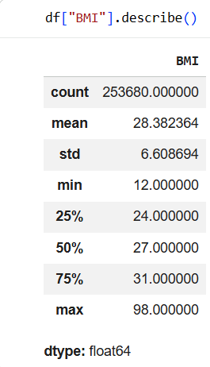
The dataset contains 253,680 records. Category 0 accounts for 86.07% of records, while category 1 accounts for 13.93%. The mean BMI is 28.38 and the median BMI is 27.
6.2 Chi-square Test of Independence
The Chi-square test of independence was used to determine whether recorded diabetes status was statistically associated with the selected categorical variables.
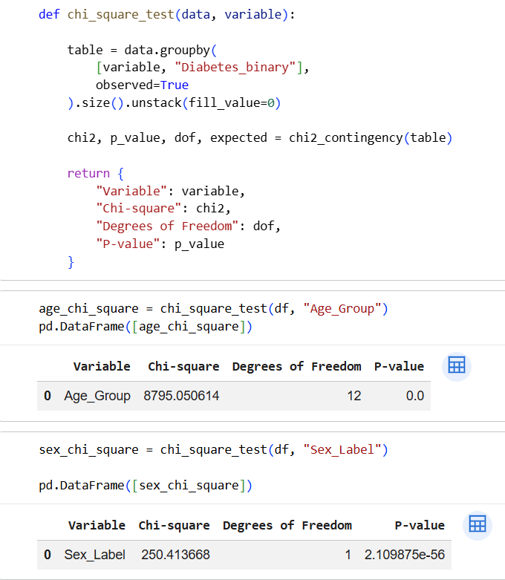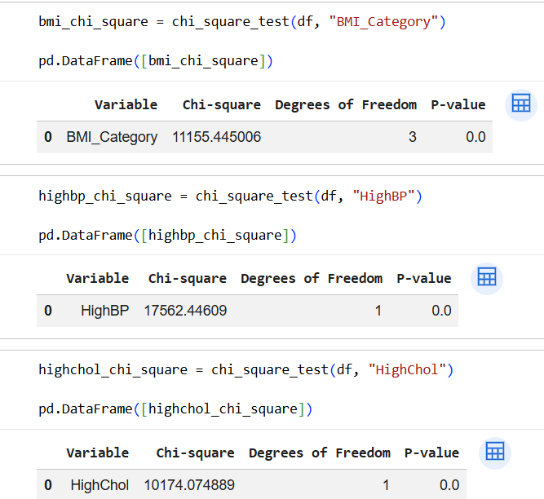
- Null hypothesis (H₀): The variables are independent.
- Alternative hypothesis (H₁): The variables are associated.
- Significance level: 0.05.
The test was applied to age group, sex, BMI category, HighBP and HighChol.
All five tests were statistically significant at the 0.05 level. Therefore, the null hypothesis of independence was rejected for each variable. The results indicate associations with recorded diabetes status but do not establish causation.
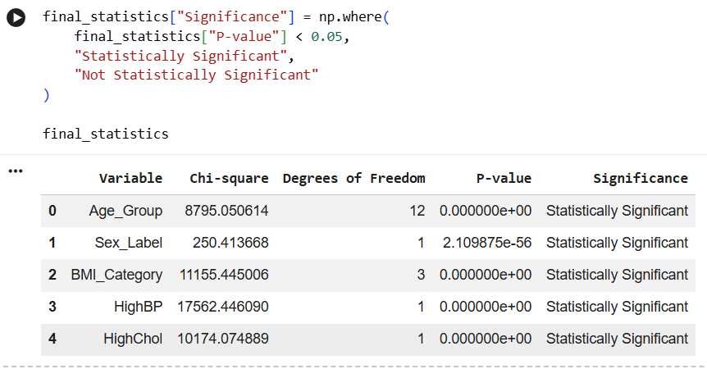
6.3 Cramér’s V
Cramér’s V was used to measure the strength of association between recorded diabetes status and each categorical variable.
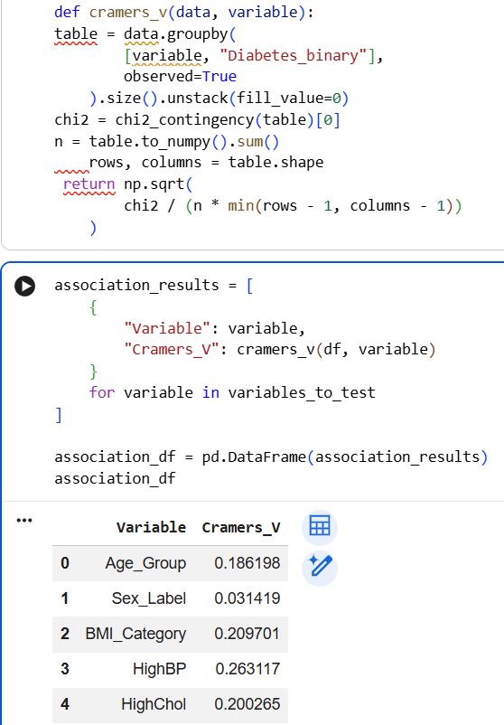
The calculated Cramér’s V values are presented below.
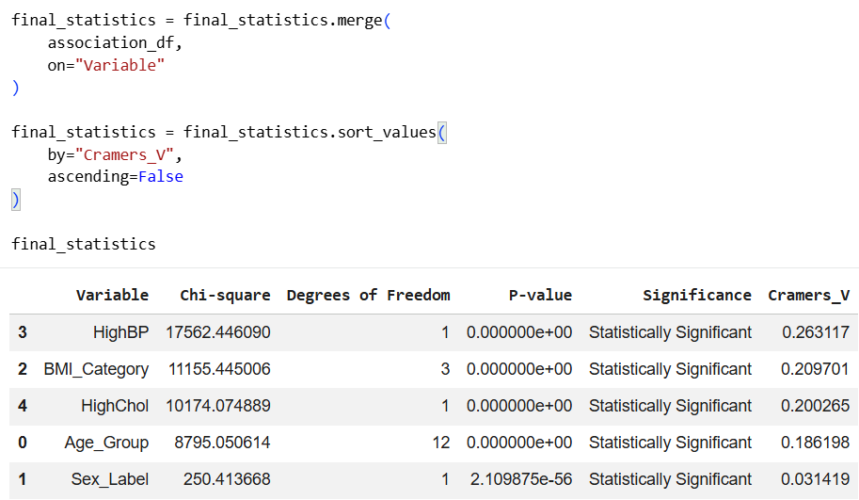
HighBP had the largest Cramér’s V value, whereas sex had the smallest. Although all five tests were statistically significant, the strength of association varied across the variables. These findings describe patterns in the dataset and should not be interpreted as evidence of cause and effect.
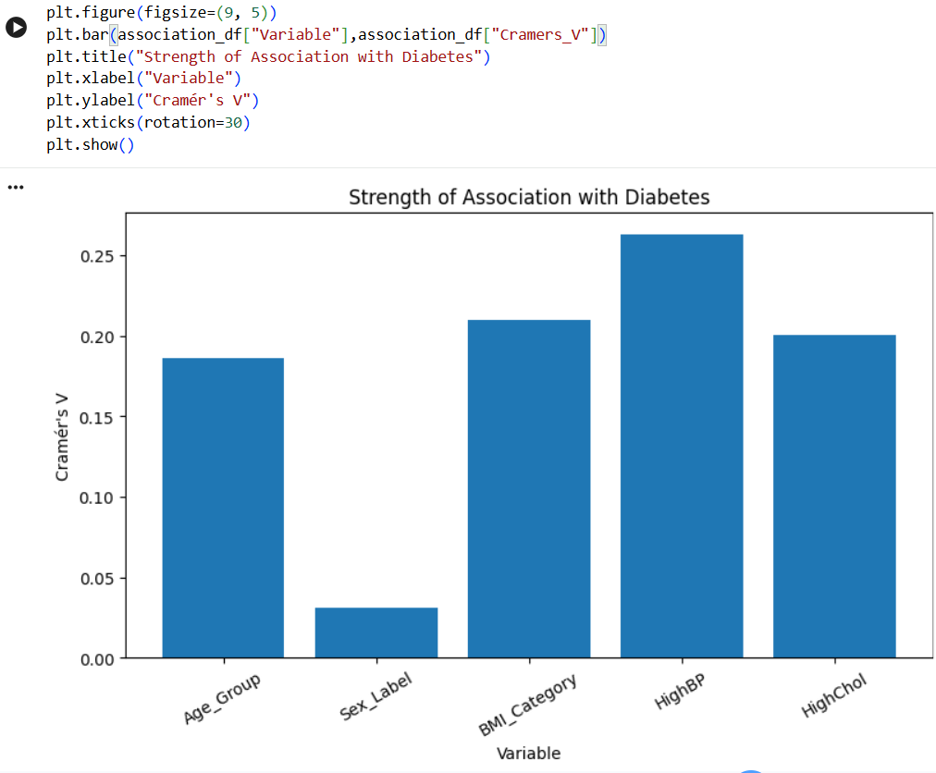

7.Key Insights & Interpretation
- Age and Diabetes Occurrence: The recorded diabetes-status category 1 rate generally increased with age, reaching 21.85% at age code 11 before declining slightly in the oldest age groups. This suggests an association between age and recorded diabetes status.
- Sex and Diabetes Occurrence: The category 1 rate was 15.16% among males and 12.97% among females. Although the difference was statistically significant, Cramér’s V (0.0314) indicated a weak association.
- BMI and Diabetes Occurrence: The category 1 rate was 23.40% in the obese BMI category, compared with 5.70% in the normal BMI category. This indicates a notable association between BMI category and recorded diabetes status.
- High Blood Pressure and Diabetes Occurrence: The category 1 rate was 24.45% among records reporting high blood pressure, compared with 6.04% among records without high blood pressure. Among the variables examined, high blood pressure had the strongest association with recorded diabetes status (Cramér’s V = 0.2631).
- High Cholesterol and Diabetes Occurrence: The category 1 rate was 22.01% among records reporting high cholesterol, compared with 7.98% among records without high cholesterol. This indicates an association between high cholesterol and recorded diabetes status.
The chi-square tests showed statistically significant associations for all five variables (p < 0.001). However, the strength of the associations varied. These findings describe patterns in the dataset and do not establish cause-and-effect relationships.

8. Conclusion & Future Scope
8.1 Conclusion
This project, Analysing the Association of Age and Sex with Diabetes Occurrence: An Exploratory Data Analysis Using the CDC Diabetes Health Indicators Dataset, examined the distribution of recorded diabetes status across age groups and sex categories using Python.
Exploratory Data Analysis was performed using descriptive statistics, data visualizations, and cross-tabulations. Chi-square tests and Cramér’s V were used to examine statistical associations and understand their strength.
The analysis showed that the recorded diabetes-status category 1 rate generally increased with age, reaching 21.85% at age code 11 before declining in the oldest age groups. The rate was 12.97% among female records and 15.16% among male records. Supporting comparisons also showed higher category 1 rates among records in the obese BMI category and among those reporting high blood pressure or high cholesterol.
The statistical results indicated associations between the selected variables and recorded diabetes status. However, the strength of these associations differed, and statistical significance alone did not indicate a strong relationship. Since the project is based on exploratory and statistical analysis of existing data, the findings do not establish causal relationships or provide predictive conclusions.
Overall, the project demonstrates how Python-based data analysis can be used to identify and interpret patterns in diabetes-related health indicators.
8.2 Future Scope
Future work can extend this analysis while maintaining the project's focus on interpretable statistical findings.
- Detailed age and sex comparison: Further examine the combined relationship between age groups, sex, and recorded diabetes status.
- Further association analysis: Investigate the relationships of BMI, high blood pressure, and high cholesterol with recorded diabetes status using appropriate statistical tests and effect-size measures.
- Improved data-quality assessment: Examine the potential influence of duplicate records and other data limitations on the findings.
- Enhanced visualization: Present age-wise, sex-wise, and combined group comparisons through clear charts and heatmaps.
- Validation using additional data: Compare the observed patterns with suitable additional datasets to assess whether similar associations appear in other populations.
These extensions would support a more detailed understanding of the observed relationships while retaining the project's emphasis on exploratory data analysis, statistical interpretation, and the distinction between association and causation.
9. References
- Centers for Disease Control and Prevention. (n.d.). Behavioral Risk Factor Surveillance System (BRFSS). https://www.cdc.gov/brfss/
- UCI Machine Learning Repository. (n.d.). CDC Diabetes Health Indicators. https://archive.ics.uci.edu/dataset/891/cdc+diabetes+health+indicators
- The pandas development team. (n.d.). pandas documentation. https://pandas.pydata.org/docs/
- Matplotlib Development Team. (n.d.). Matplotlib documentation. https://matplotlib.org/stable/
- The SciPy community. (n.d.). SciPy documentation: Statistical functions. https://docs.scipy.org/doc/scipy/reference/stats.html

10. AI Tool Usage Declaration
☐ No AI tools were used in this project.
☑ AI tools were used, as detailed below:
AI Tool Used | Purpose (e.g., debugging, documentation) | Extent of Use / Section Applied
ChatGPT | Report writing and documentation assistance | Assistance with wording, organizing content, and refining explanations in selected report sections, including Key Insights & Interpretation and Conclusion & Future Scope.

11. Project Links & Deliverables
GitHub Repository Link : https:/github.com/lavishe9/CDC-Diabetes-EDA
Python Notebook (.ipynb) File Name : Data Analytics Notebook
PBL Report File Name: PBL_Submission_Report
☑ GitHub repository includes code, notebook, and a PBL report and README

12. Report Structure Checklist (Section 8 Compliance)
S. No. | Report Section (as per Section 8 format) | Included (✓)
1 | Title Page | ✓
2 | Introduction & Problem Statement | ✓
3 | Dataset Description & Source | ✓
4 | Data Cleaning & Preprocessing | ✓
5 |  | ✓
  Exploratory Data Analysis (EDA)
6 |  | ✓
  Data Visualization & Observations
7 | Statistical Analysis (Basic) | ✓
8 | Key Insights & Interpretation | ✓
9 | Conclusion & Future Scope | ✓
10 | References | ✓

13. Declaration by Student(s)

I/We hereby declare that this Mini Project Report is our own original work, prepared using publicly available/open datasets. All sources of data, references, and AI tool assistance have been duly acknowledged. I/We understand that any instance of plagiarism in code or report will attract strict academic action, as per Section 15 of the PBL guidelines.
Team Leader Signature: _____________________________________________
Team Member Signature(s): _____________________________________________
Date: ____________________________________________________________

14. For Faculty Use Only — PBL Final Report Evaluation
Evaluation Component B — PBL Final Report Submission | Mid-Term (PBL Based): 10 Marks (Section 10 of PBL Guidelines)
Evaluation Criteria | Max Marks | Marks Awarded
Data Cleaning & Preprocessing | 2
Exploratory Data Analysis (EDA) | 2
Visualization & Observations | 2
Statistical Analysis | 2
Insights, Interpretation & Conclusion | 2
Total (out of 10) | 10
Faculty Remarks:

Faculty Mentor Signature: _____________________________________________
Date: ____________________________________________________________

